2/20/25

LVIS vs. GEDI comparison: LVIS sites

**Summary:** The figures below compare estimations of AGBD from LVIS and the BIWF method. The LVIS model runs were done by Alex Rojas in 2022 (or 2023?), whereas the the GEDI model runs were done by Ian Grant in 2025; there are slight differences in their implementations which should be investigated further by re-running the LVIS data with the current model implementation. However, these differences should be minor and will apply equally to the four sites shown below.

For each of the for sites, the figures below show

- scatterplot of AGBD predictions for GEDI compared to the mean of AGBD predictions within 25 m of each GEDI footprint

- the same analysis, but dividing GEDI captures by beam type (coverage or power)

- same analysis by year

For each of the four sites, the figures below show:

1. A scatterplot of AGBD predictions for GEDI compared to the mean of AGBD predictions within 25 m of each GEDI footprint.
2. A histogram of the errors for each GEDI capture (BIWF estimate – LVIS estimate)
3. The same analysis, but dividing GEDI captures by beam type (coverage or power).
4. The same analysis by year.

**Results**: The results demonstrate variation between sites:

1. Lope has a reasonable 1-to-1 correlation, except for a separate distribution of points where GEDI underestimates LVIS. These points are disproportionately coverage beams but not exclusively. They occur in all years.
2. Mabounie has an across-the-board underestimate for GEDI, suggesting that a different biomass index to AGBD model may be necessary to correct this bias.
3. Mondah appears to be precise and unbiased.
4. Rabi has an underestimate similar to Mabounie, but not as severe.

Overall, it looks like there is significant variation between beam type but no clear patterns that I can see between years.

1. **Lope**

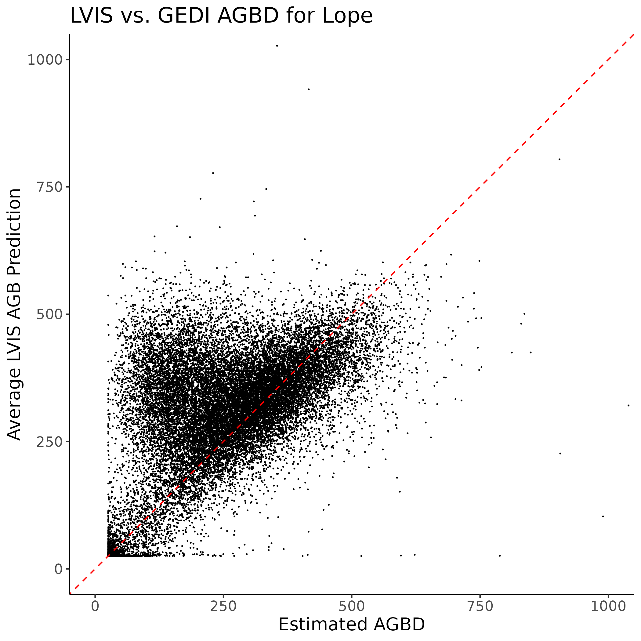

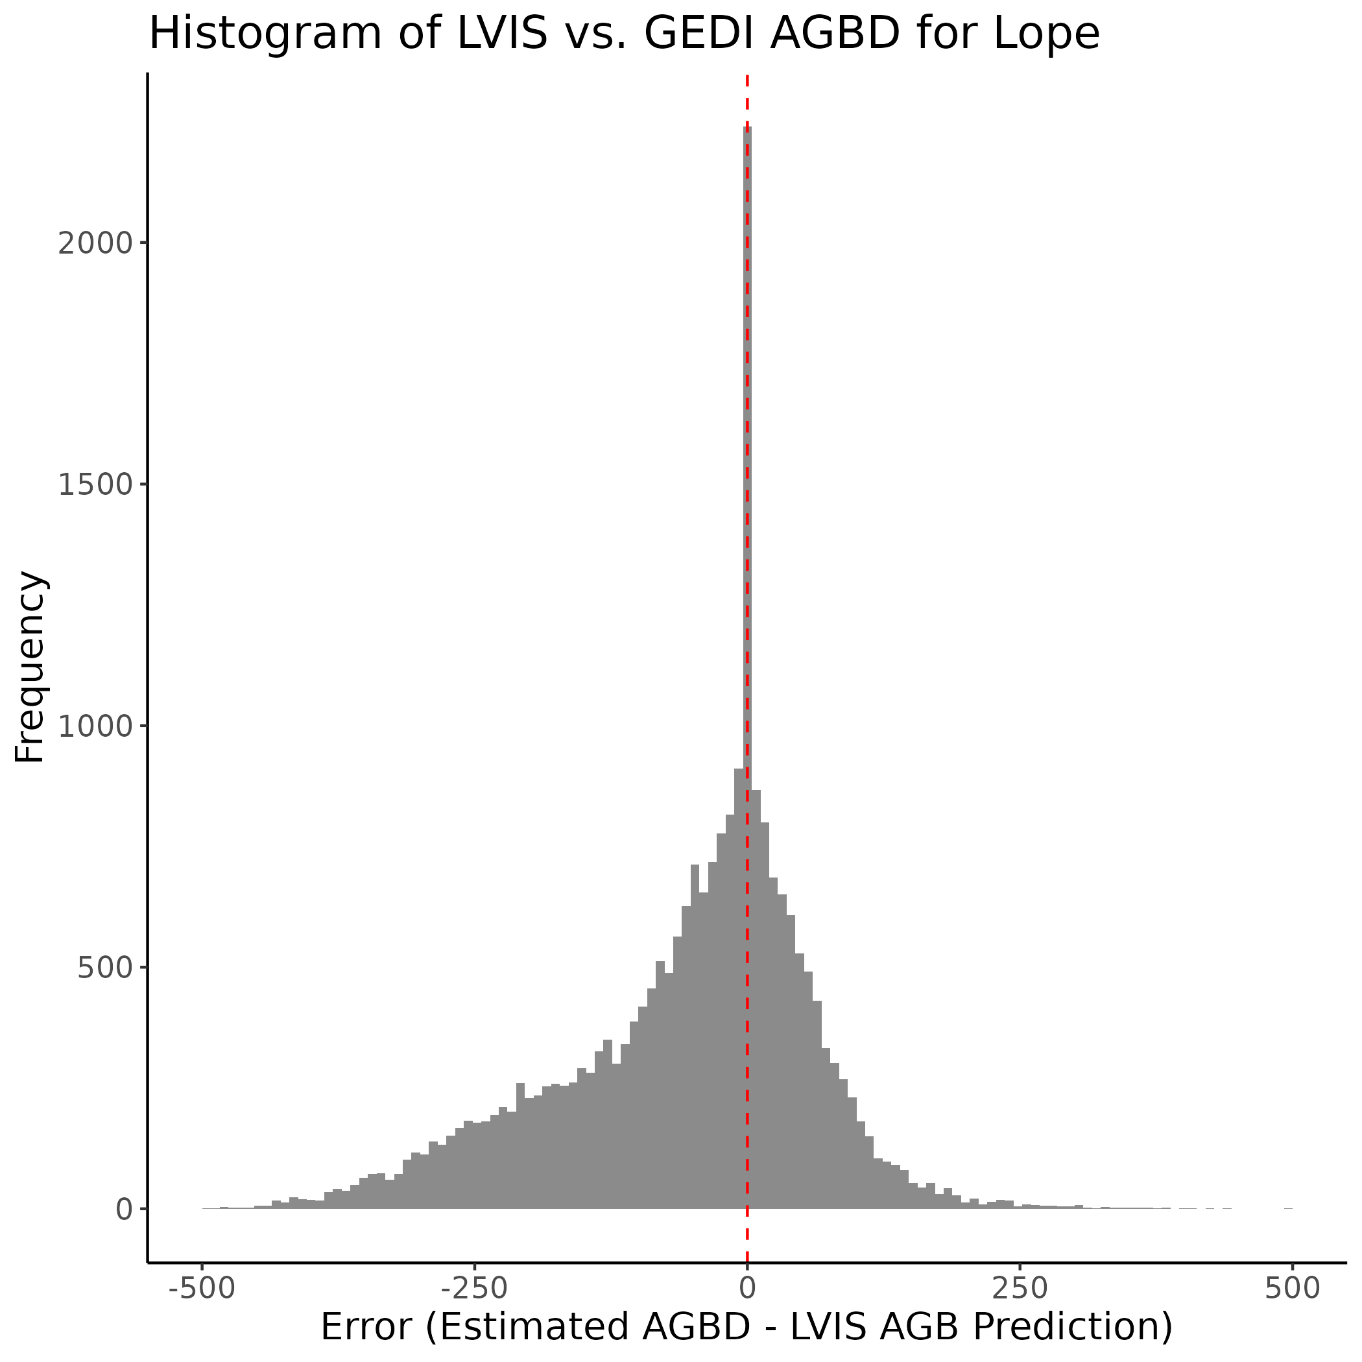

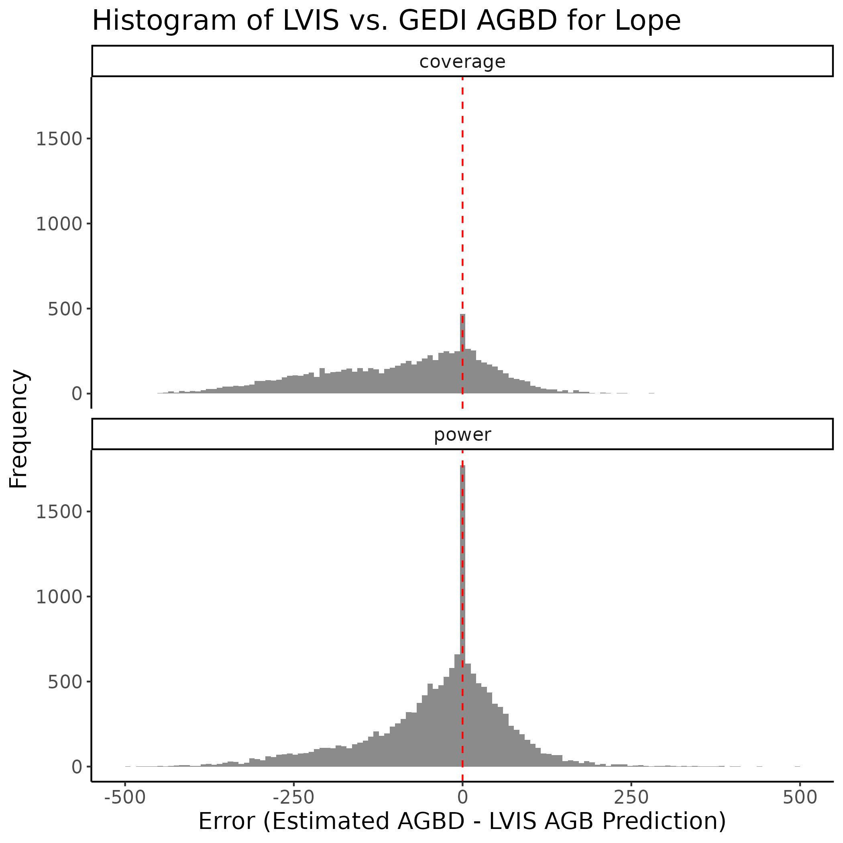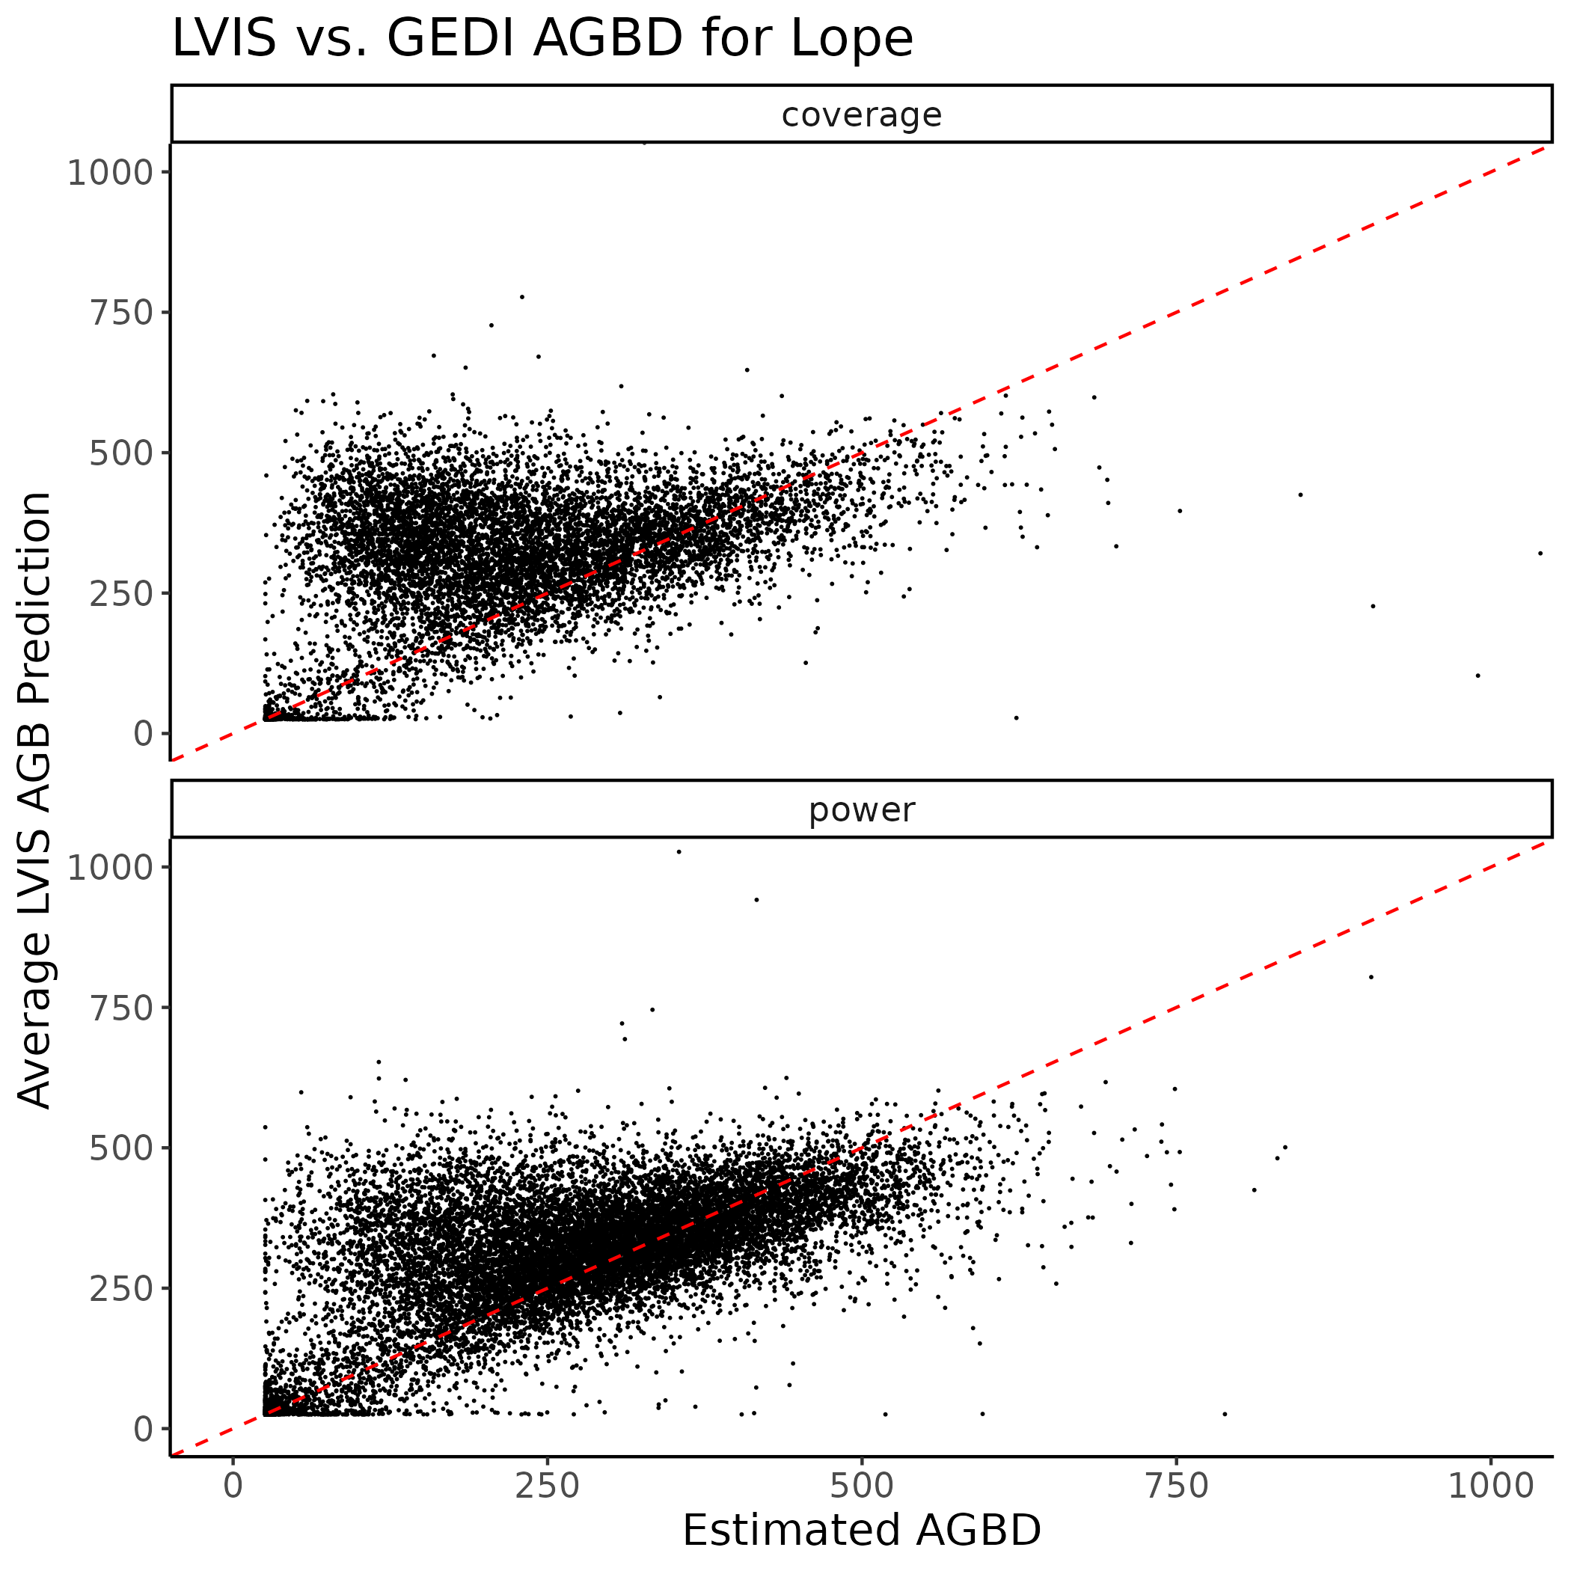

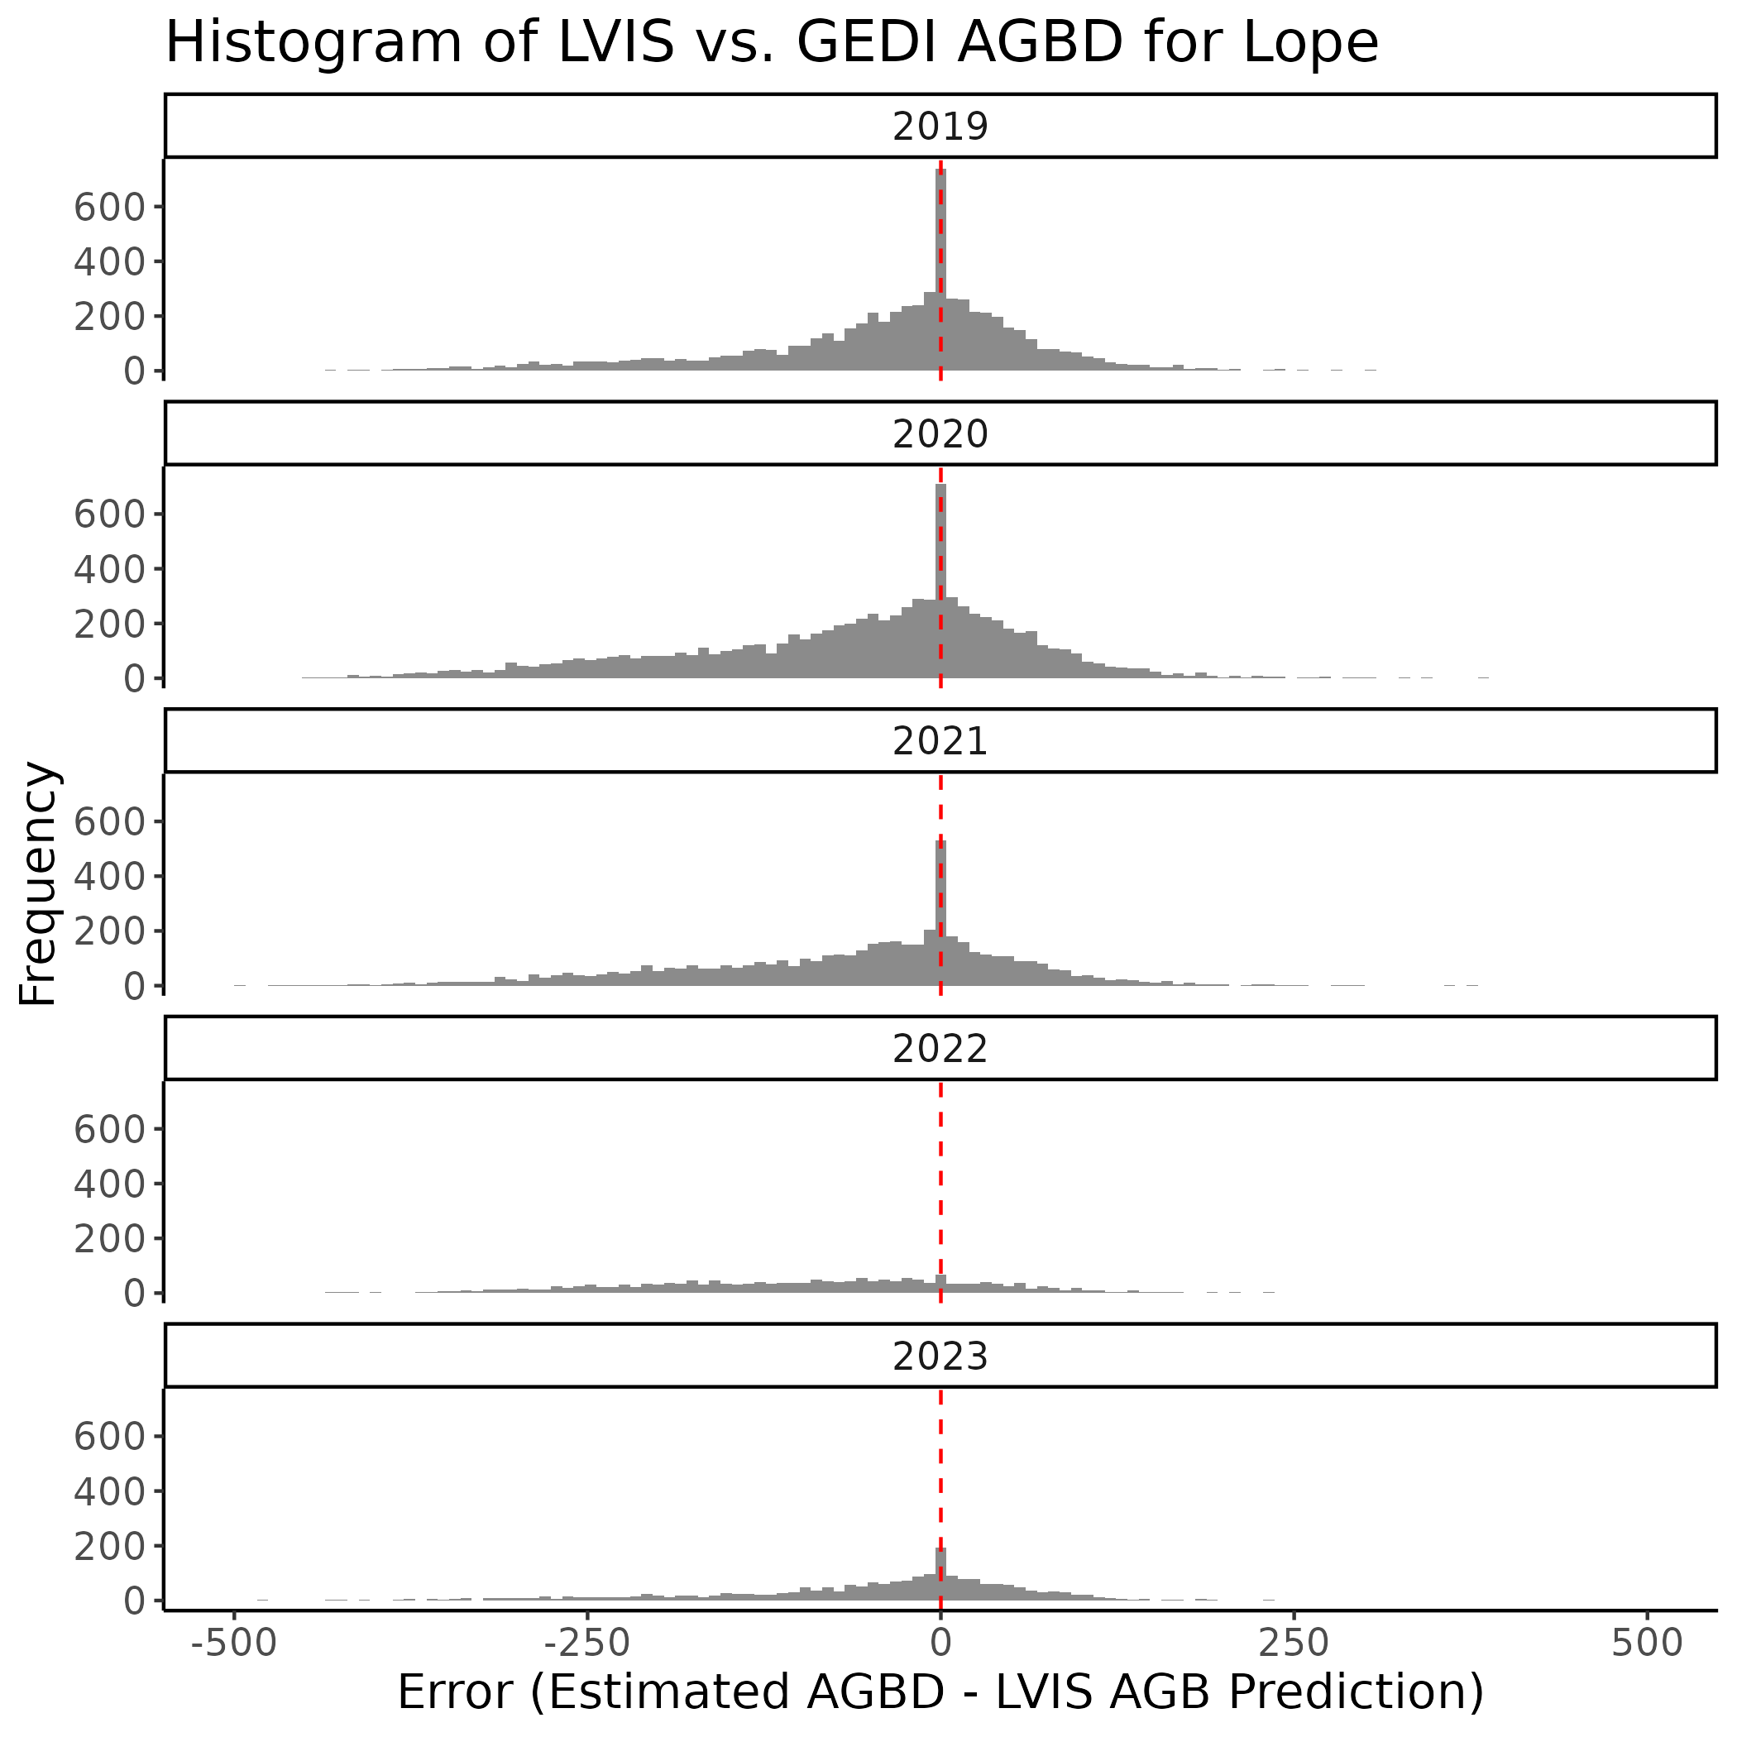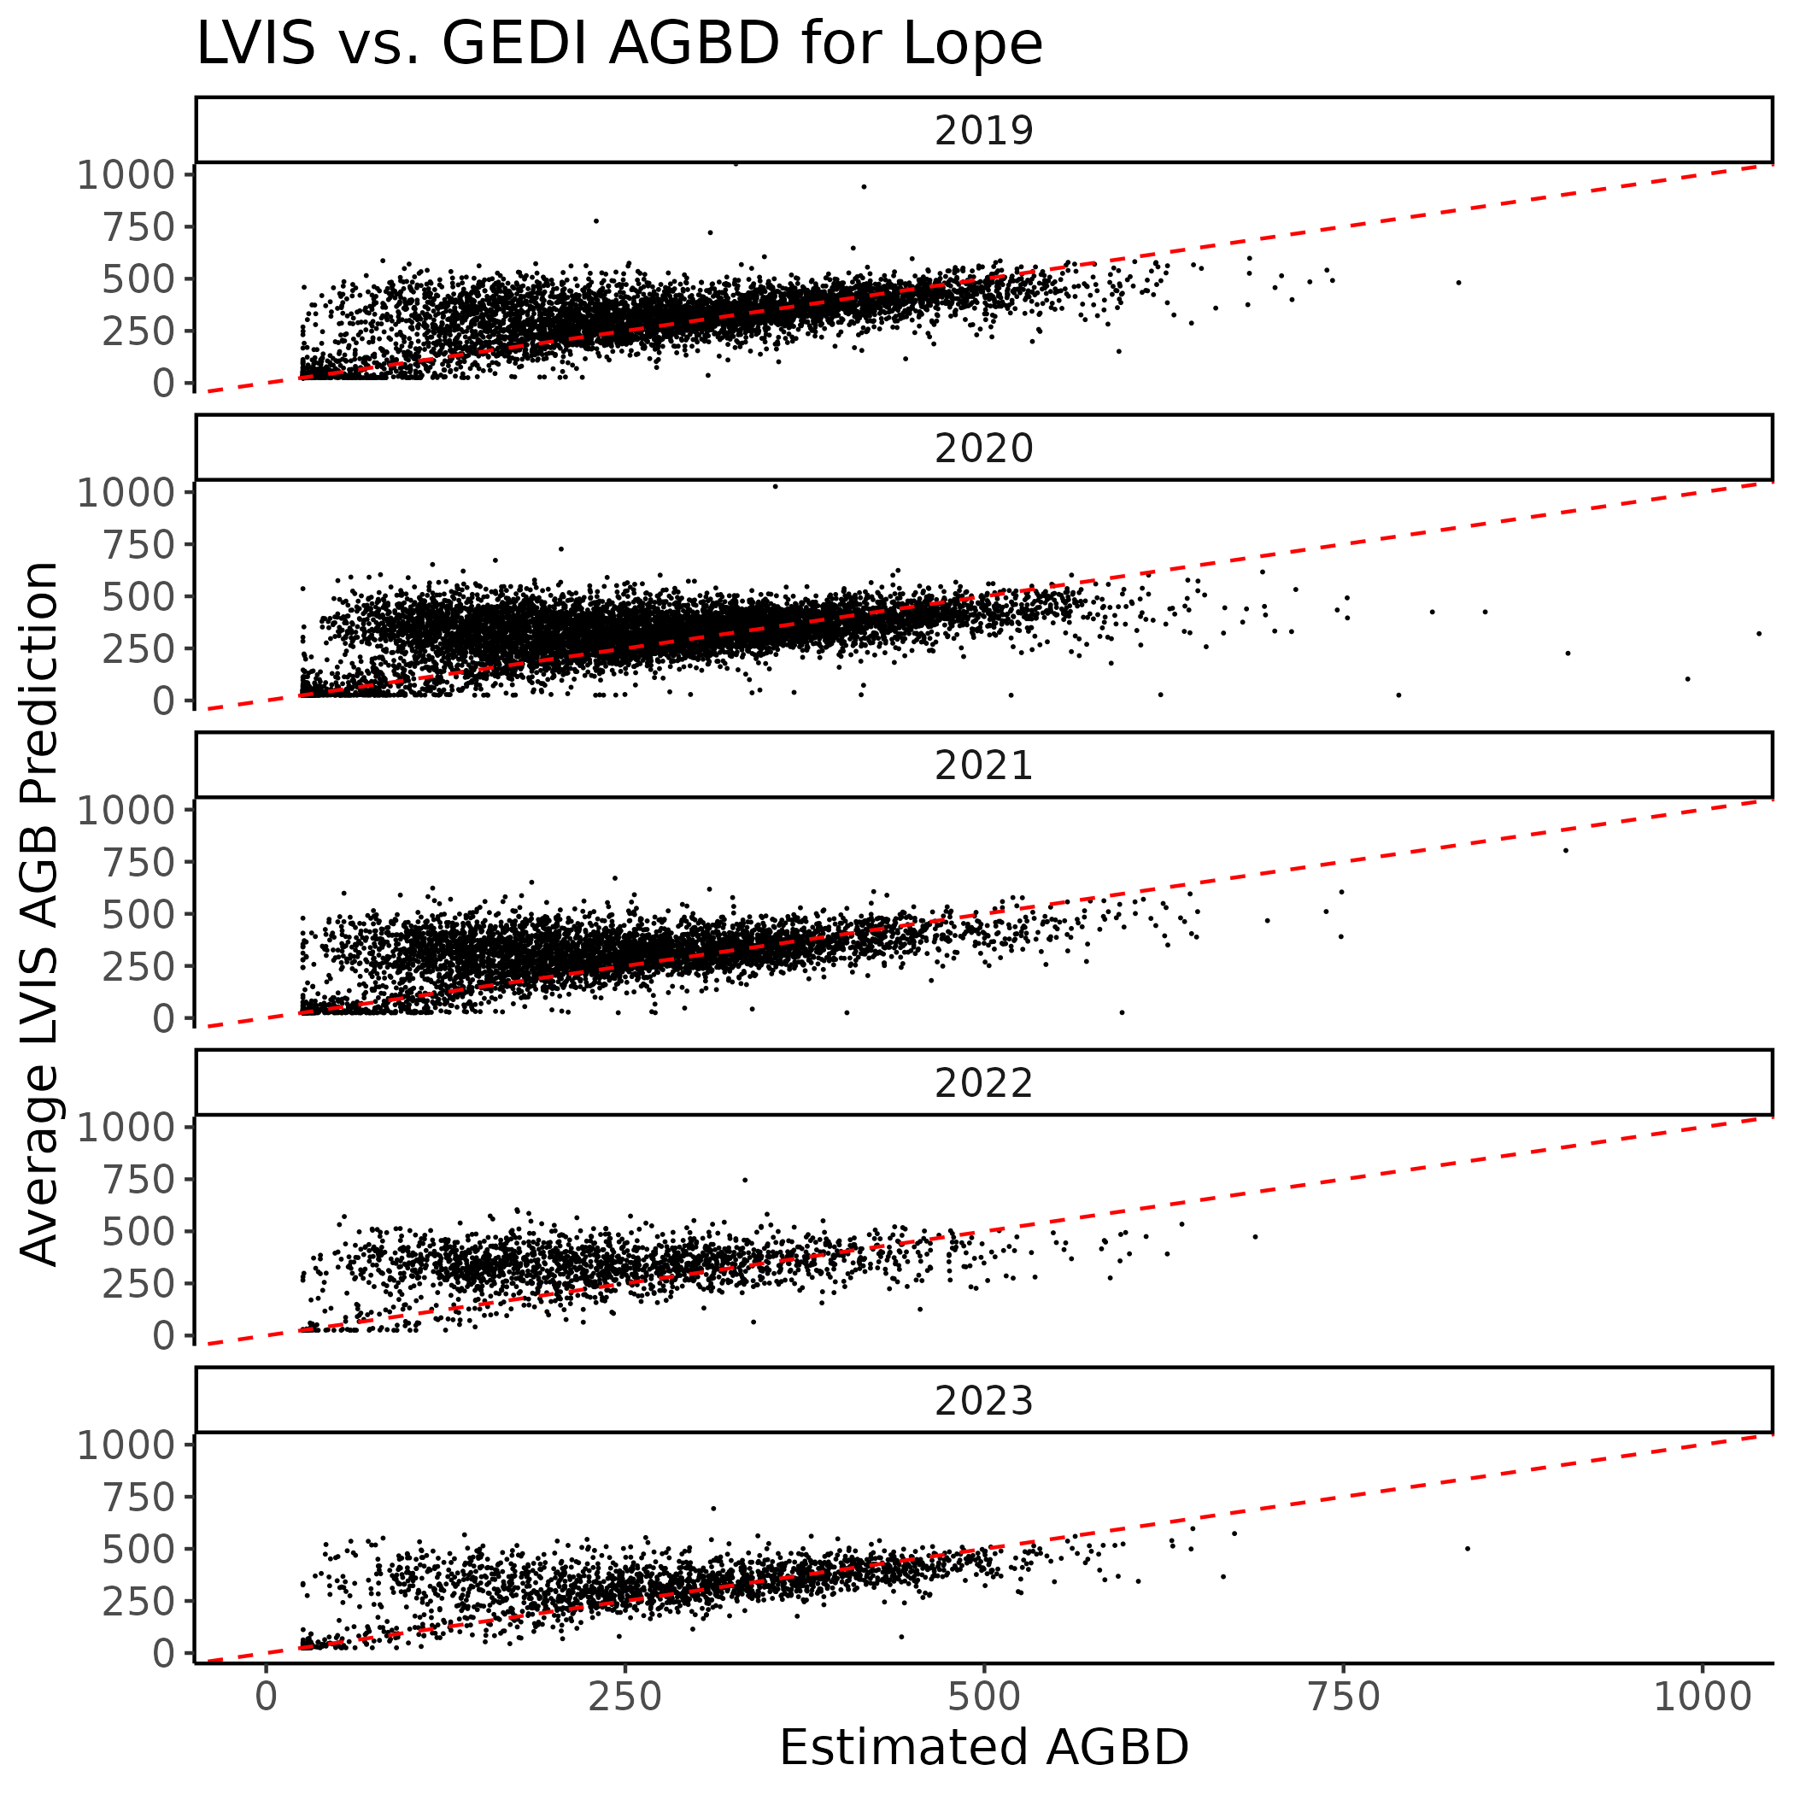

**2. Mabounie**

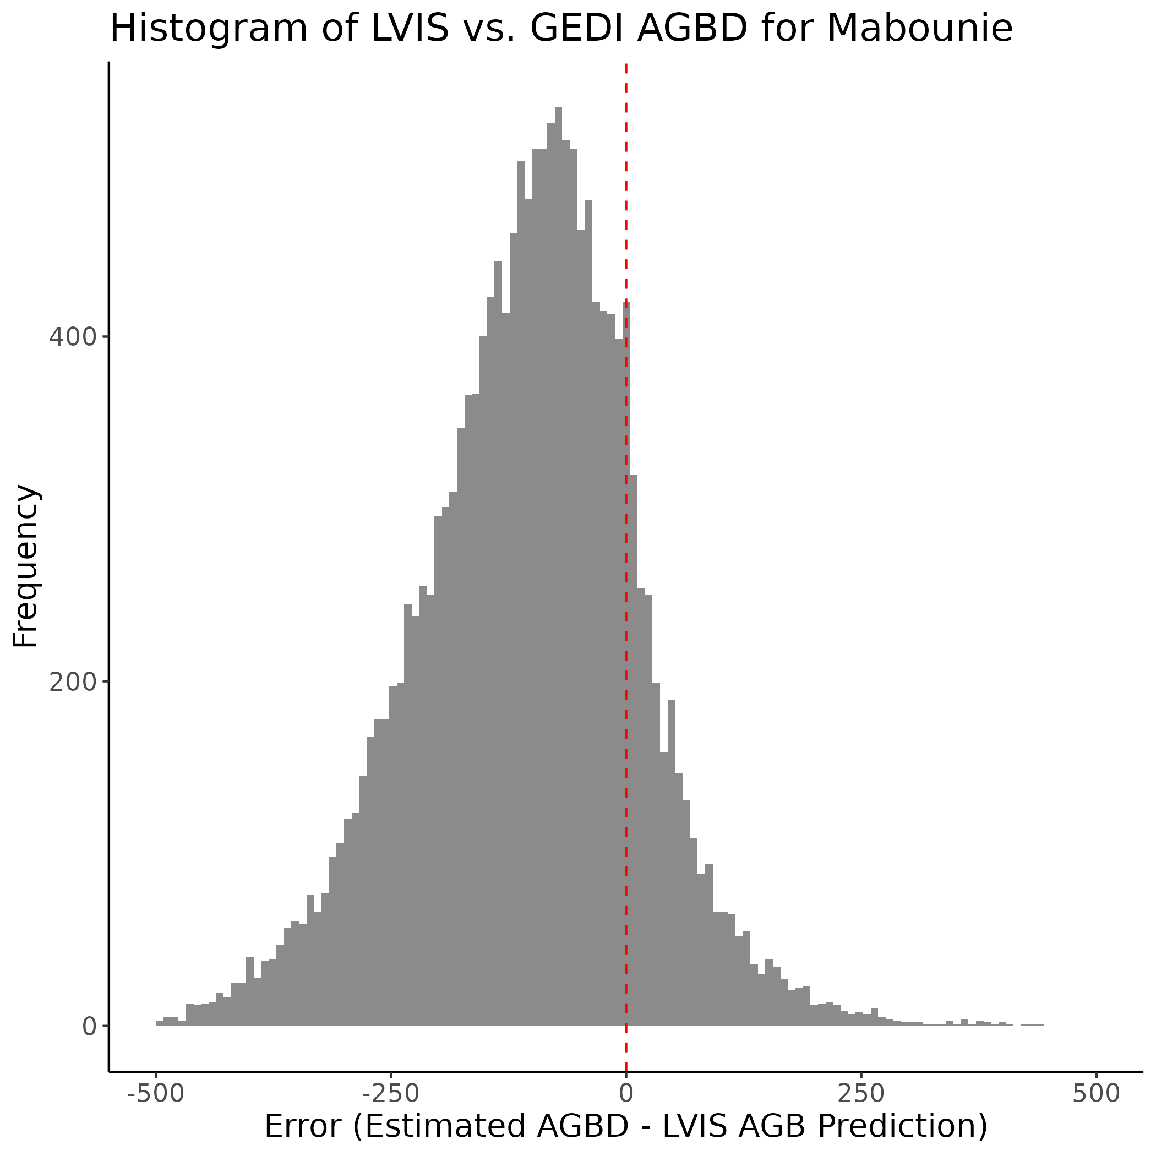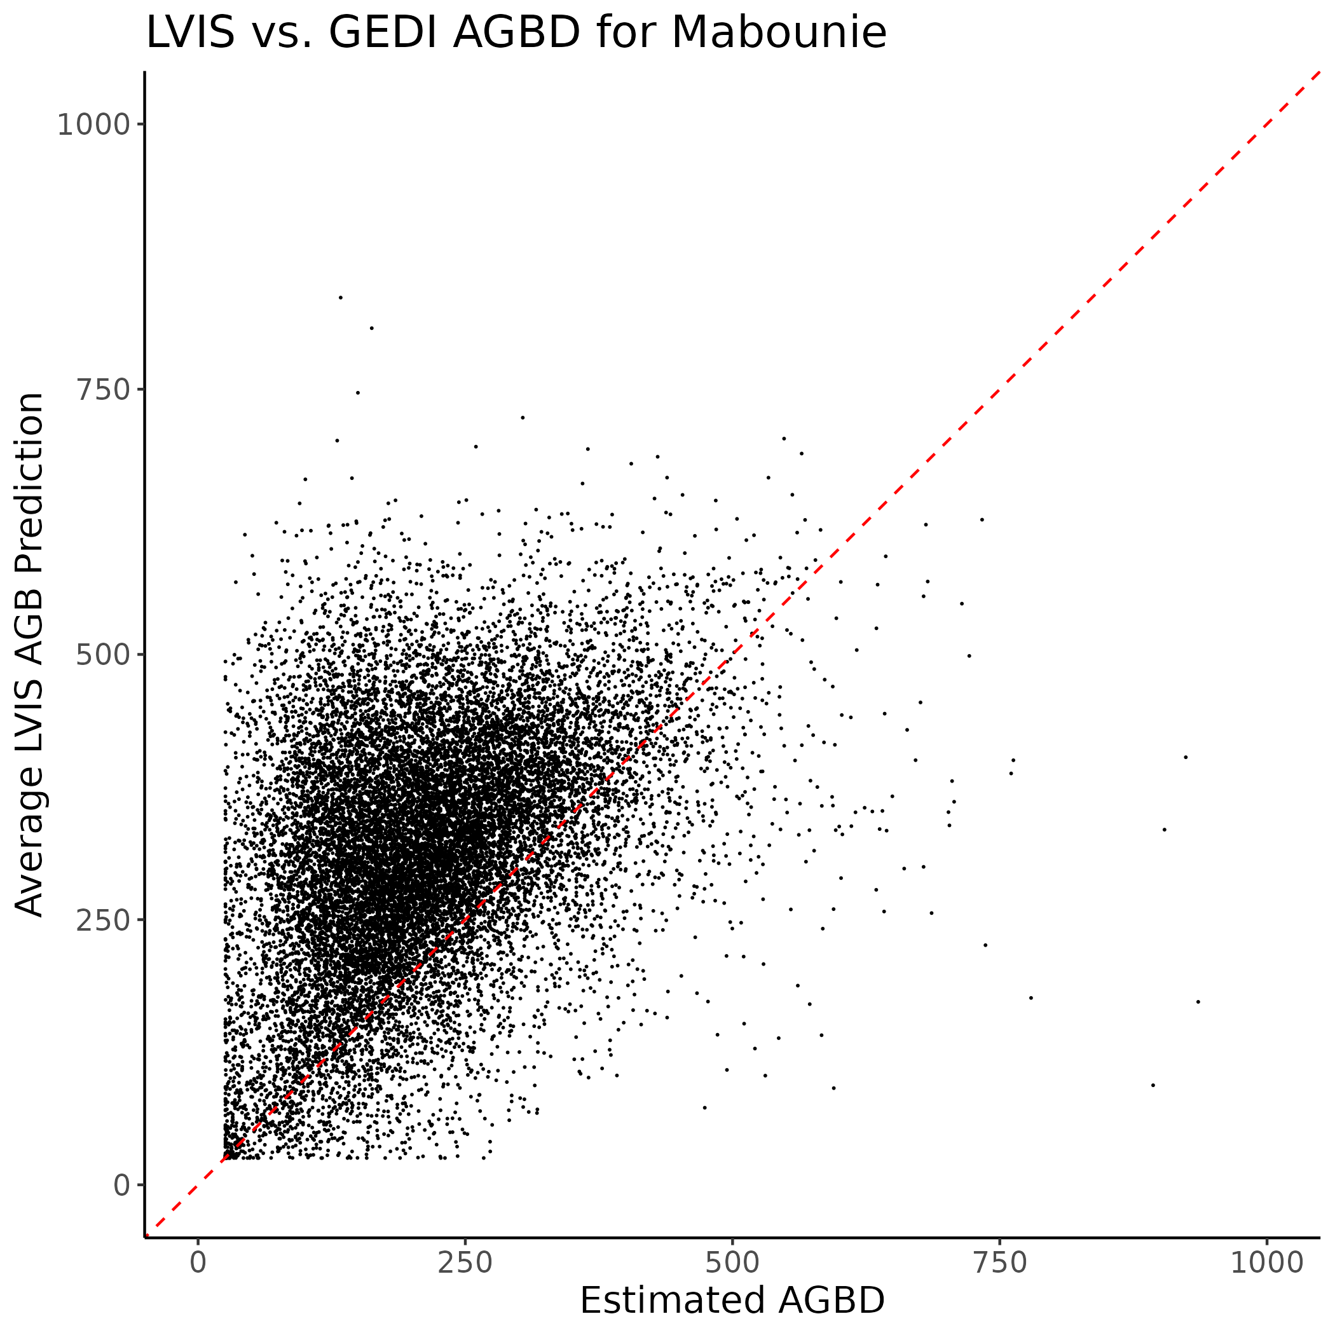

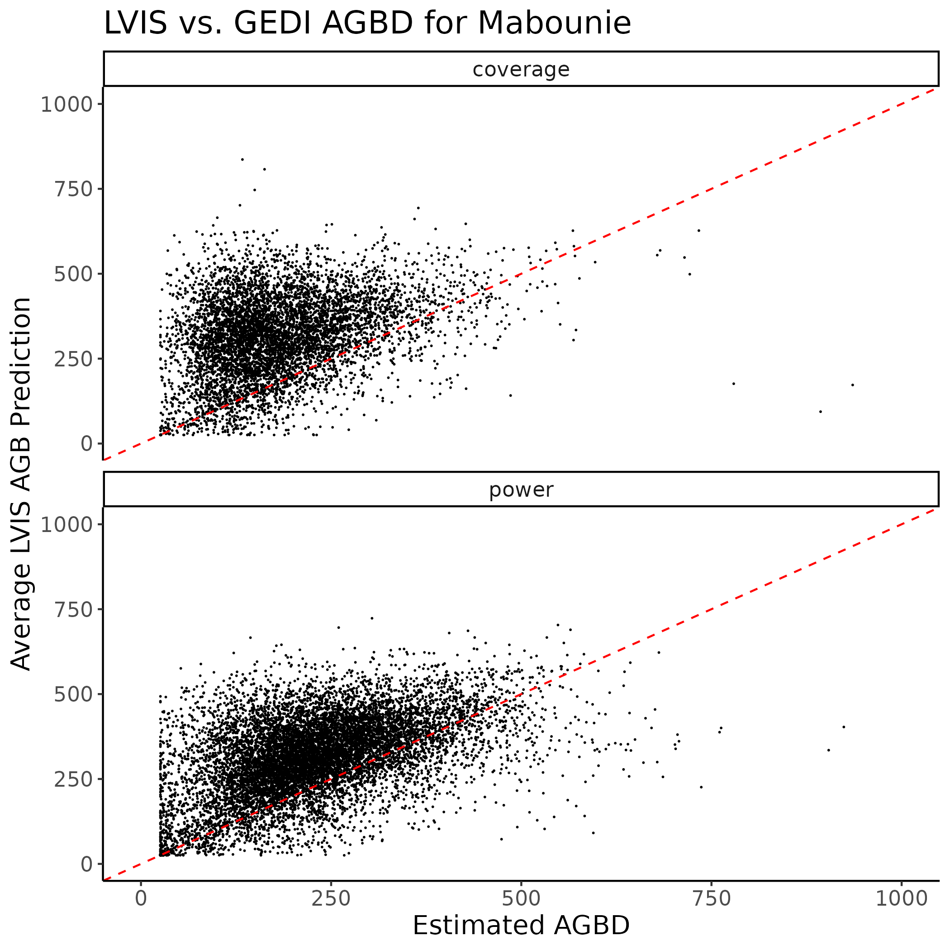

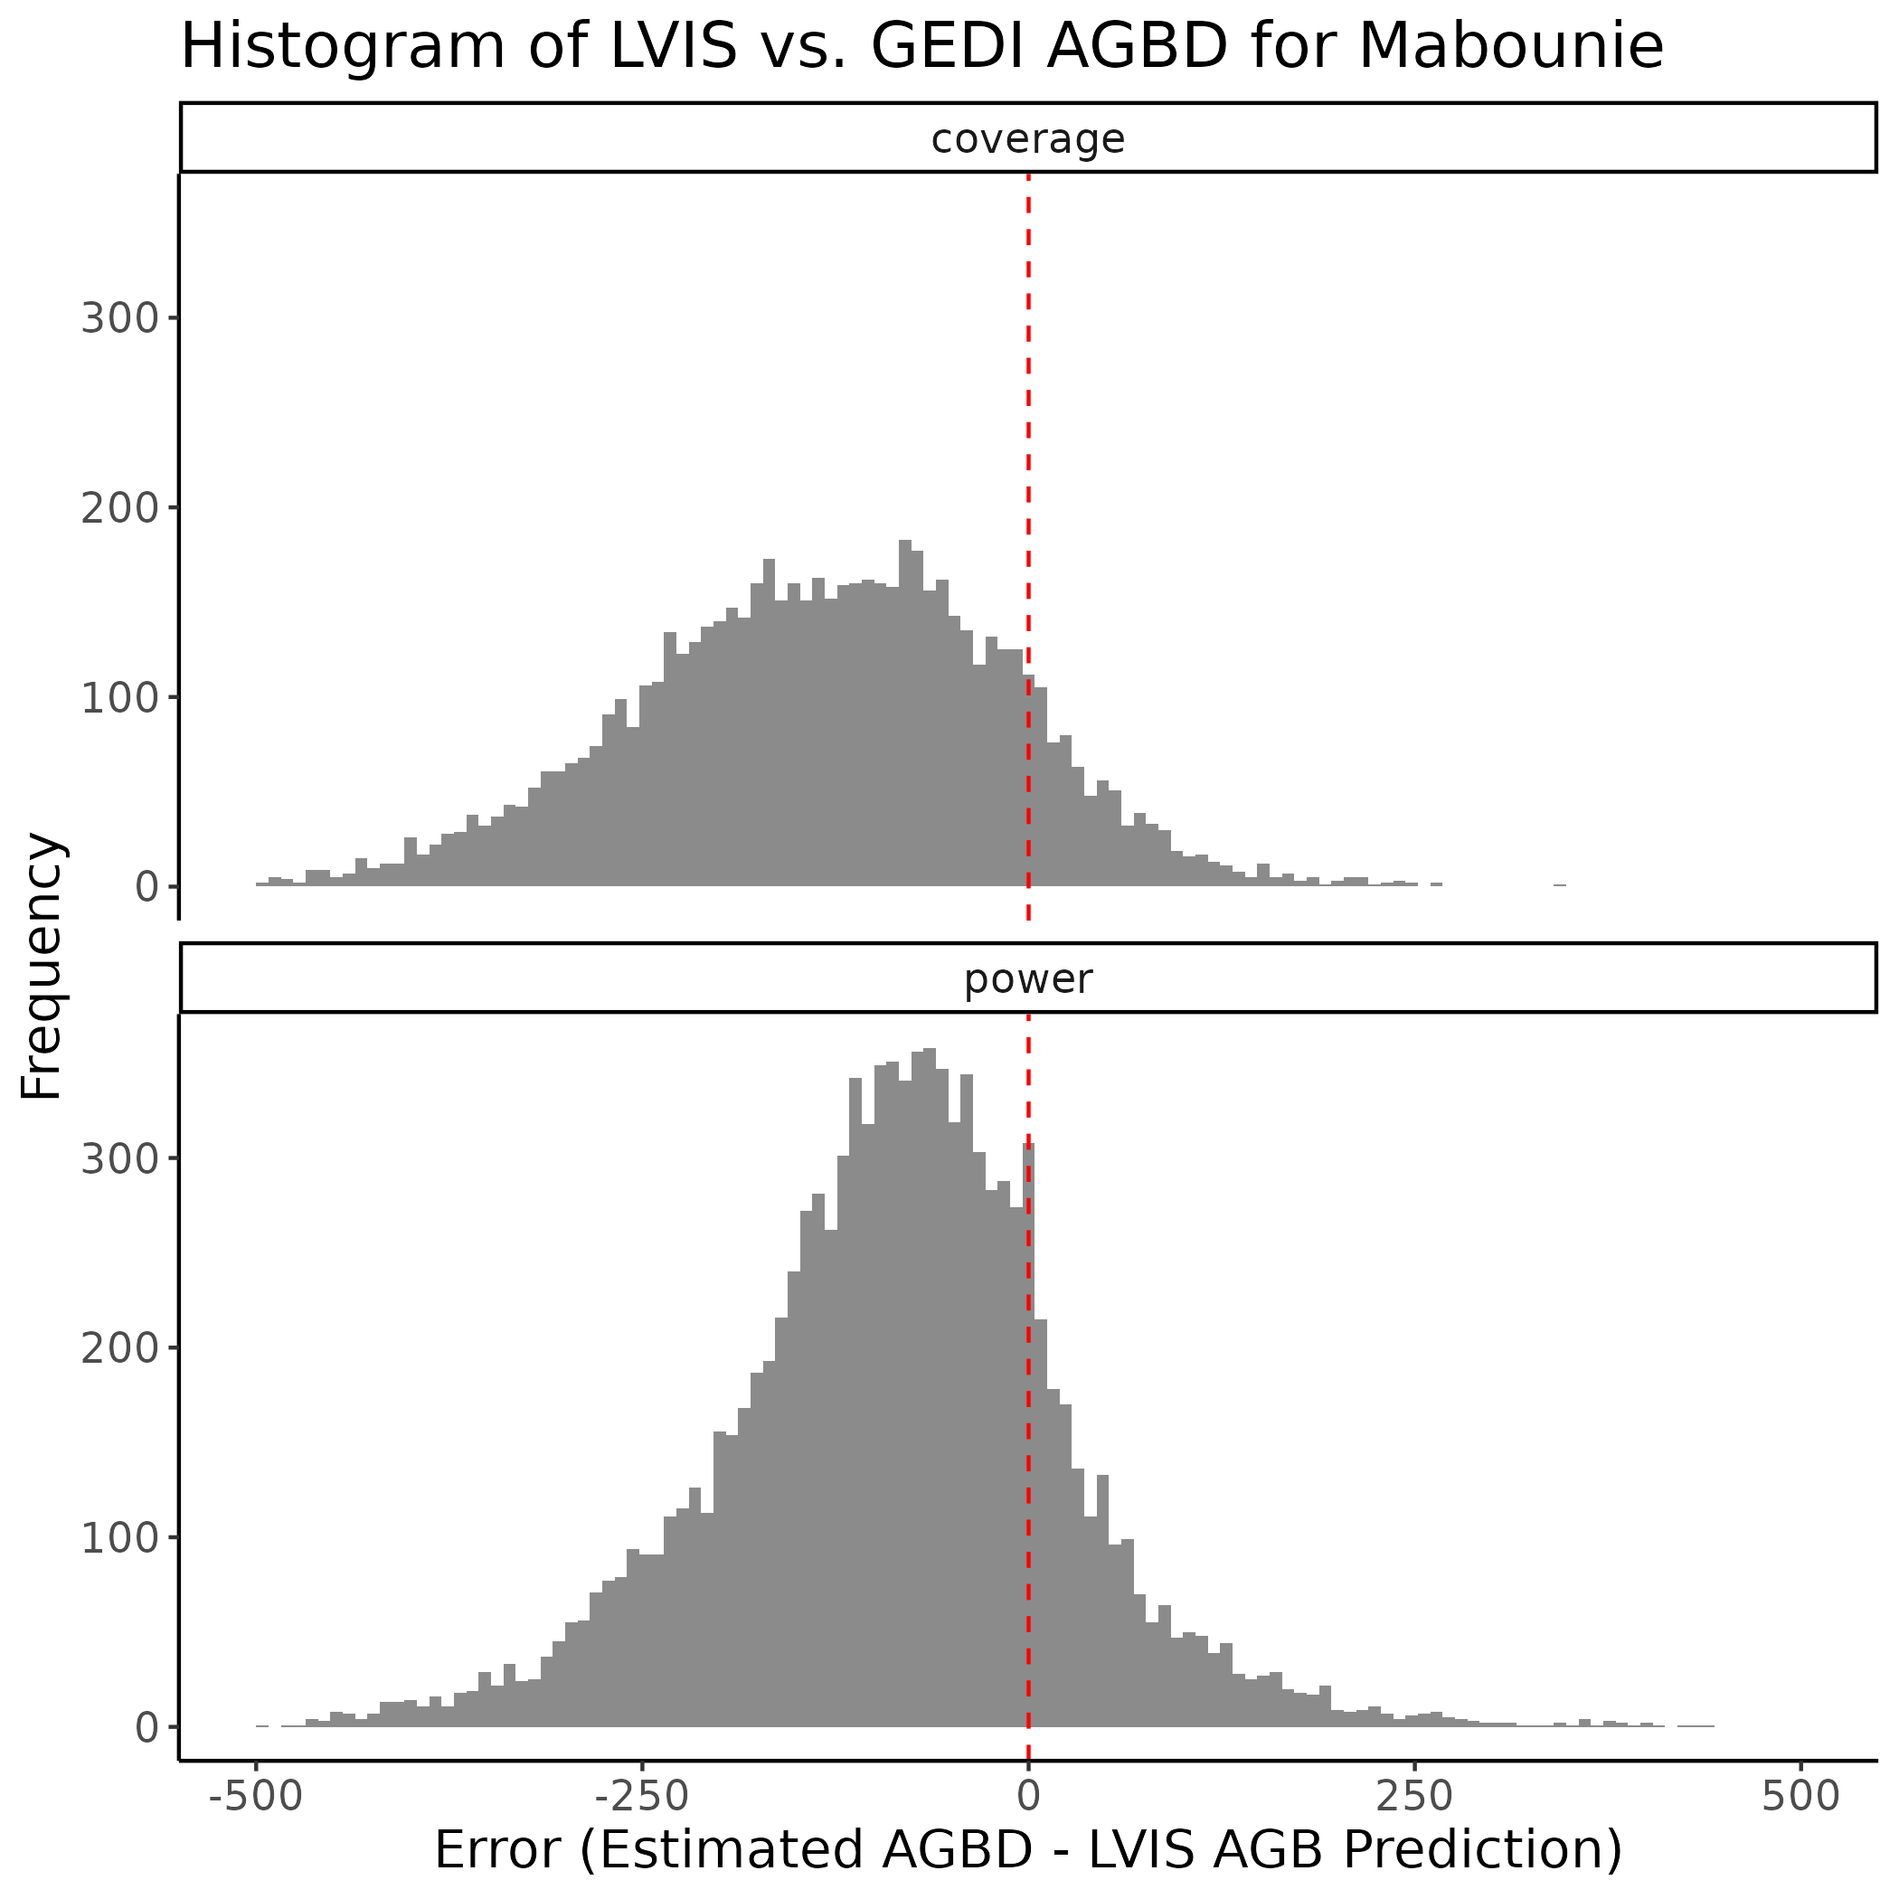

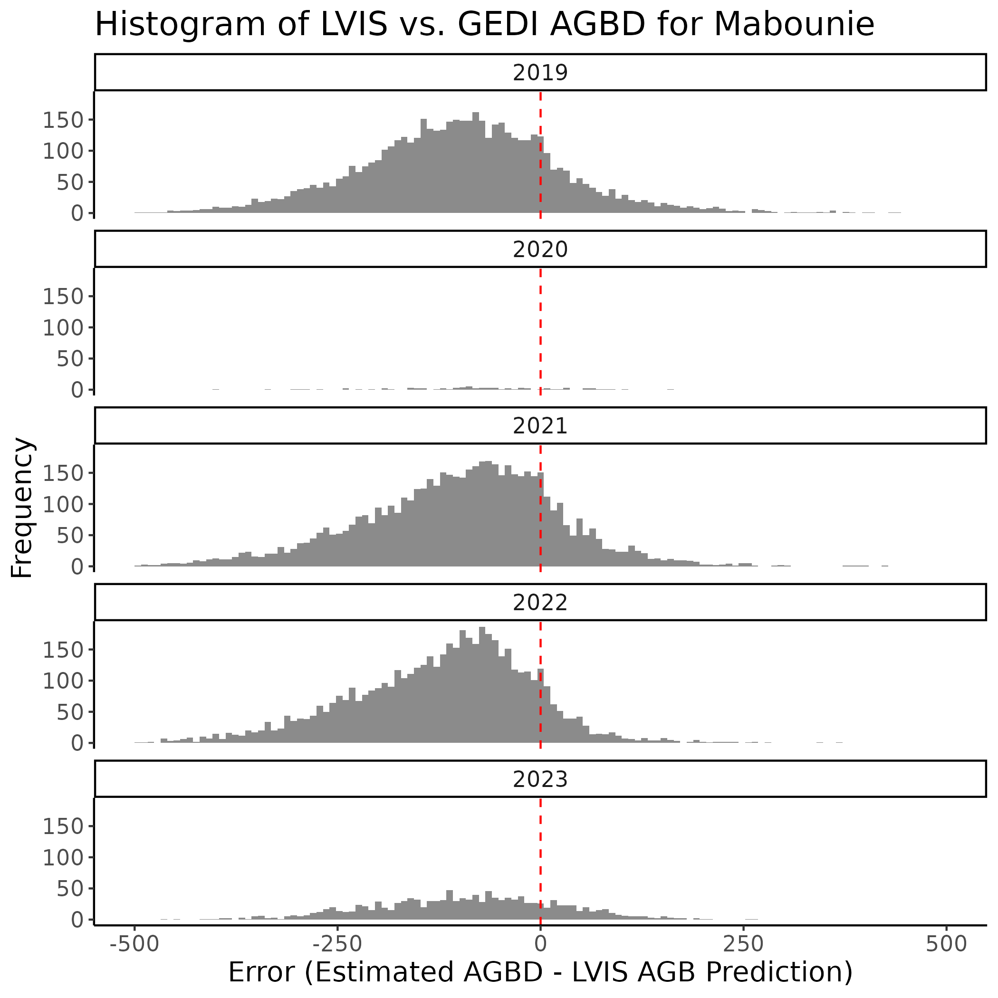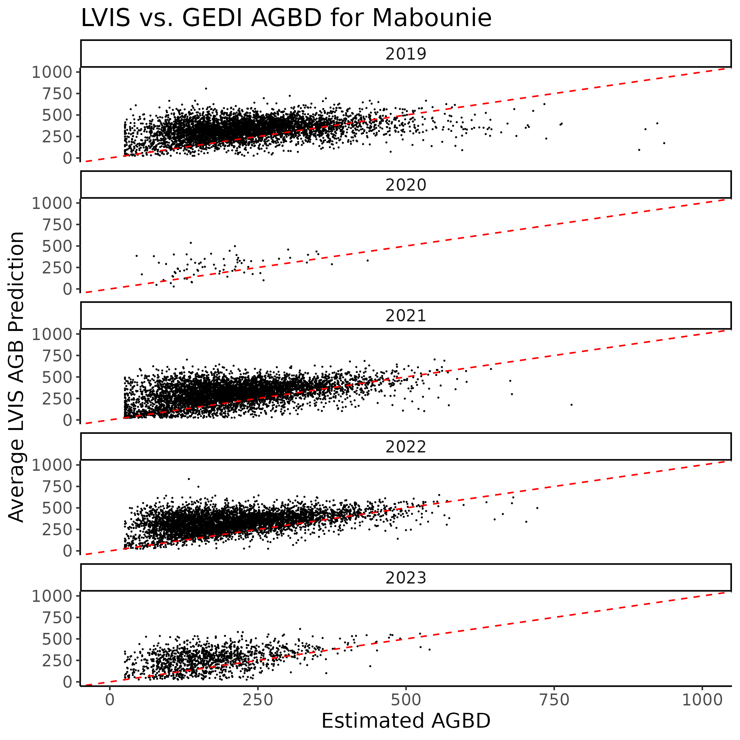

3. **Mondah**

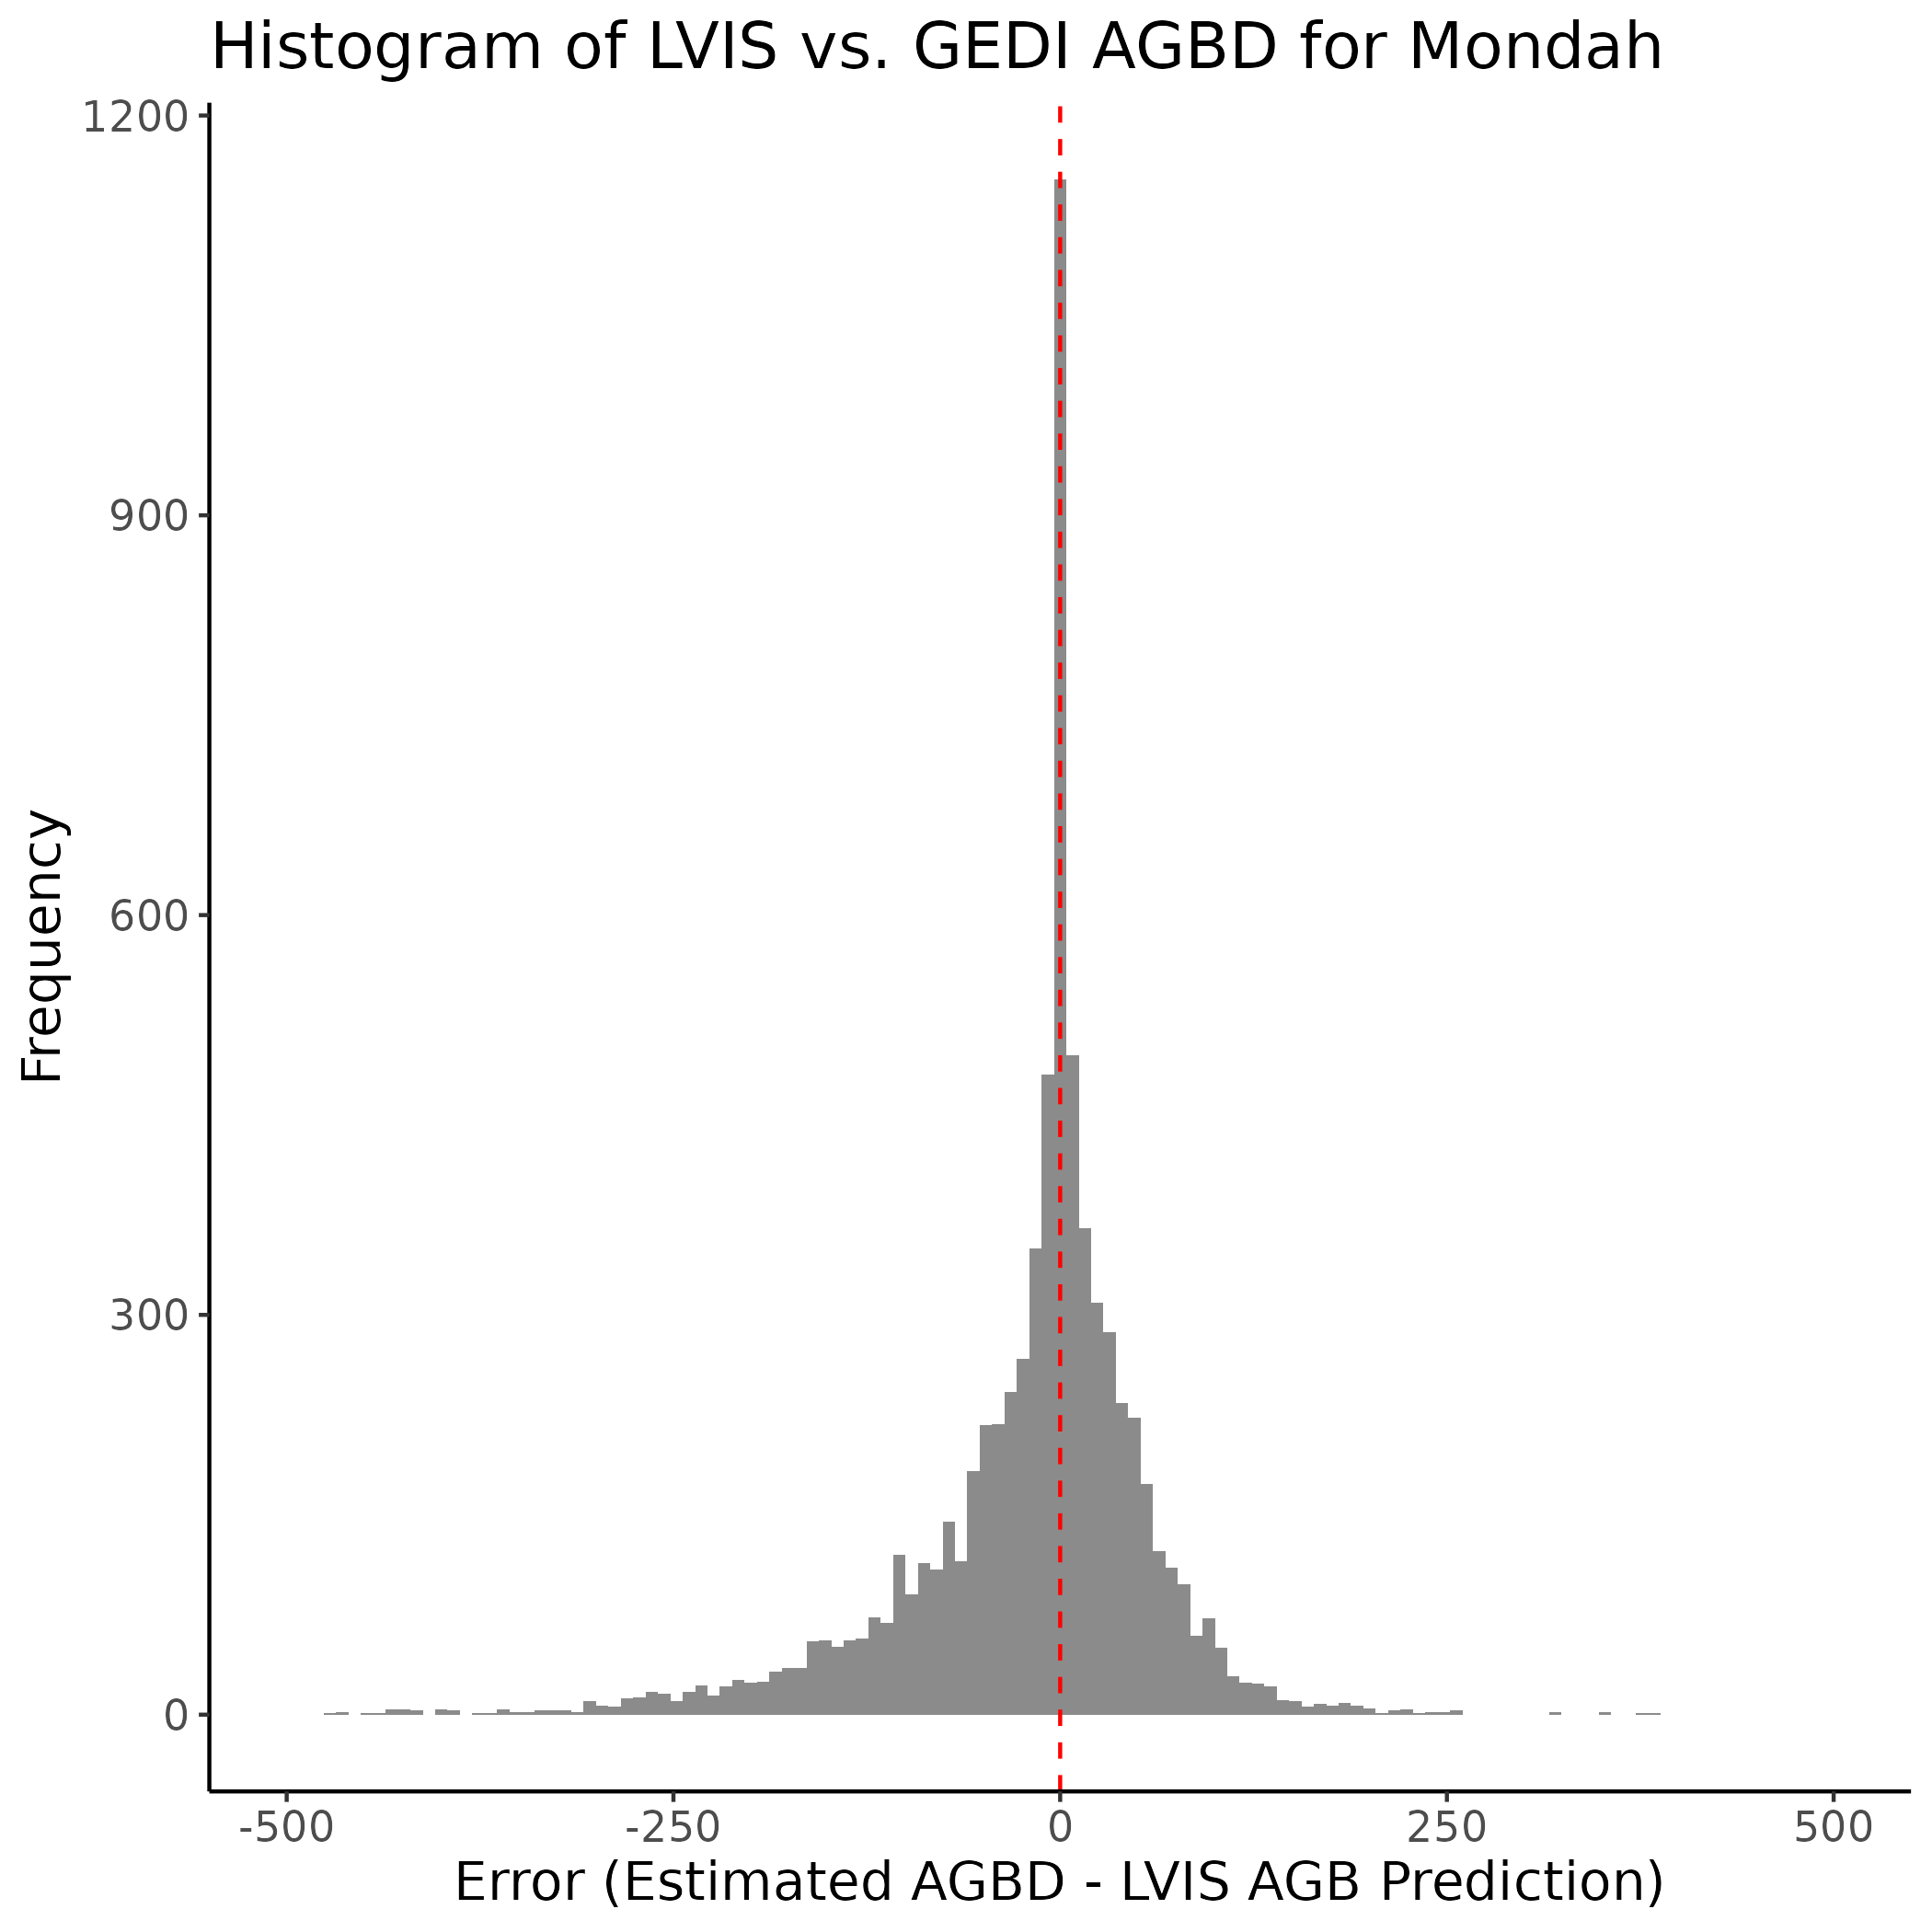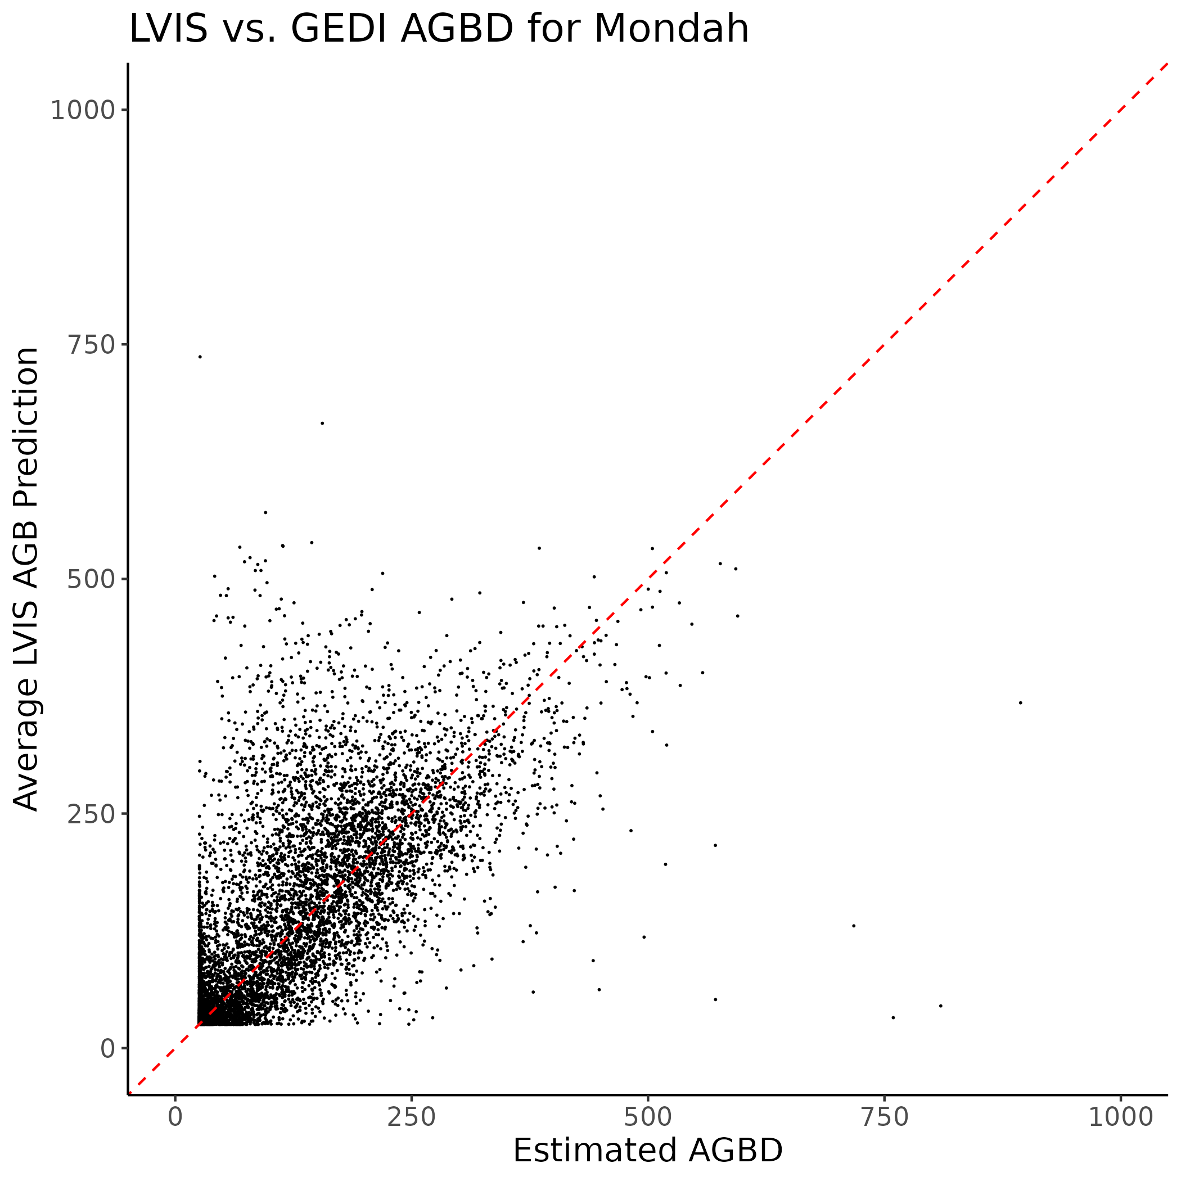

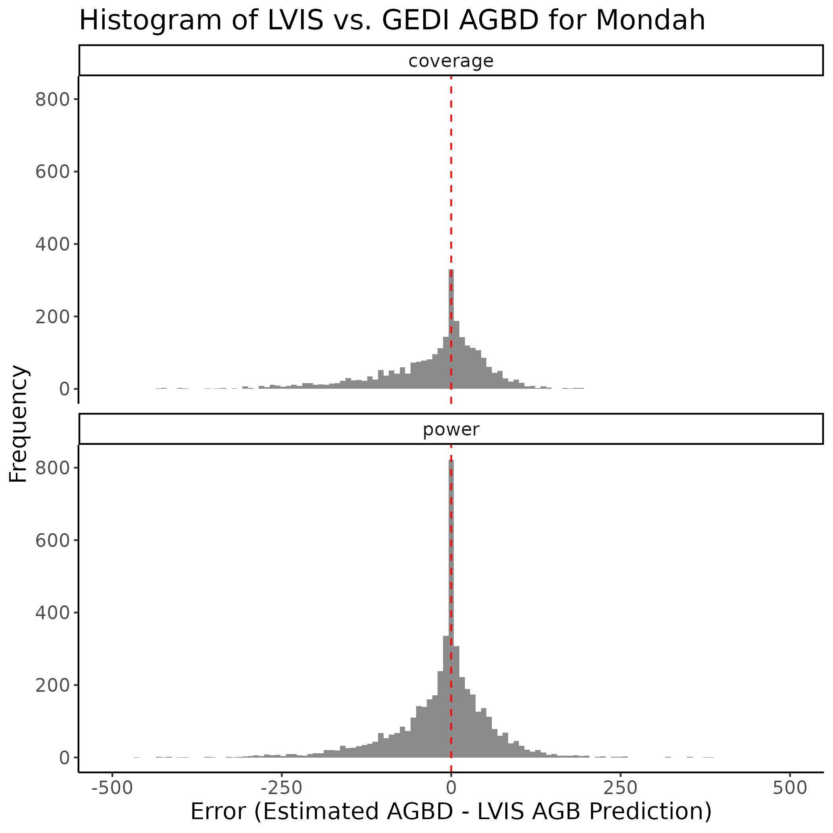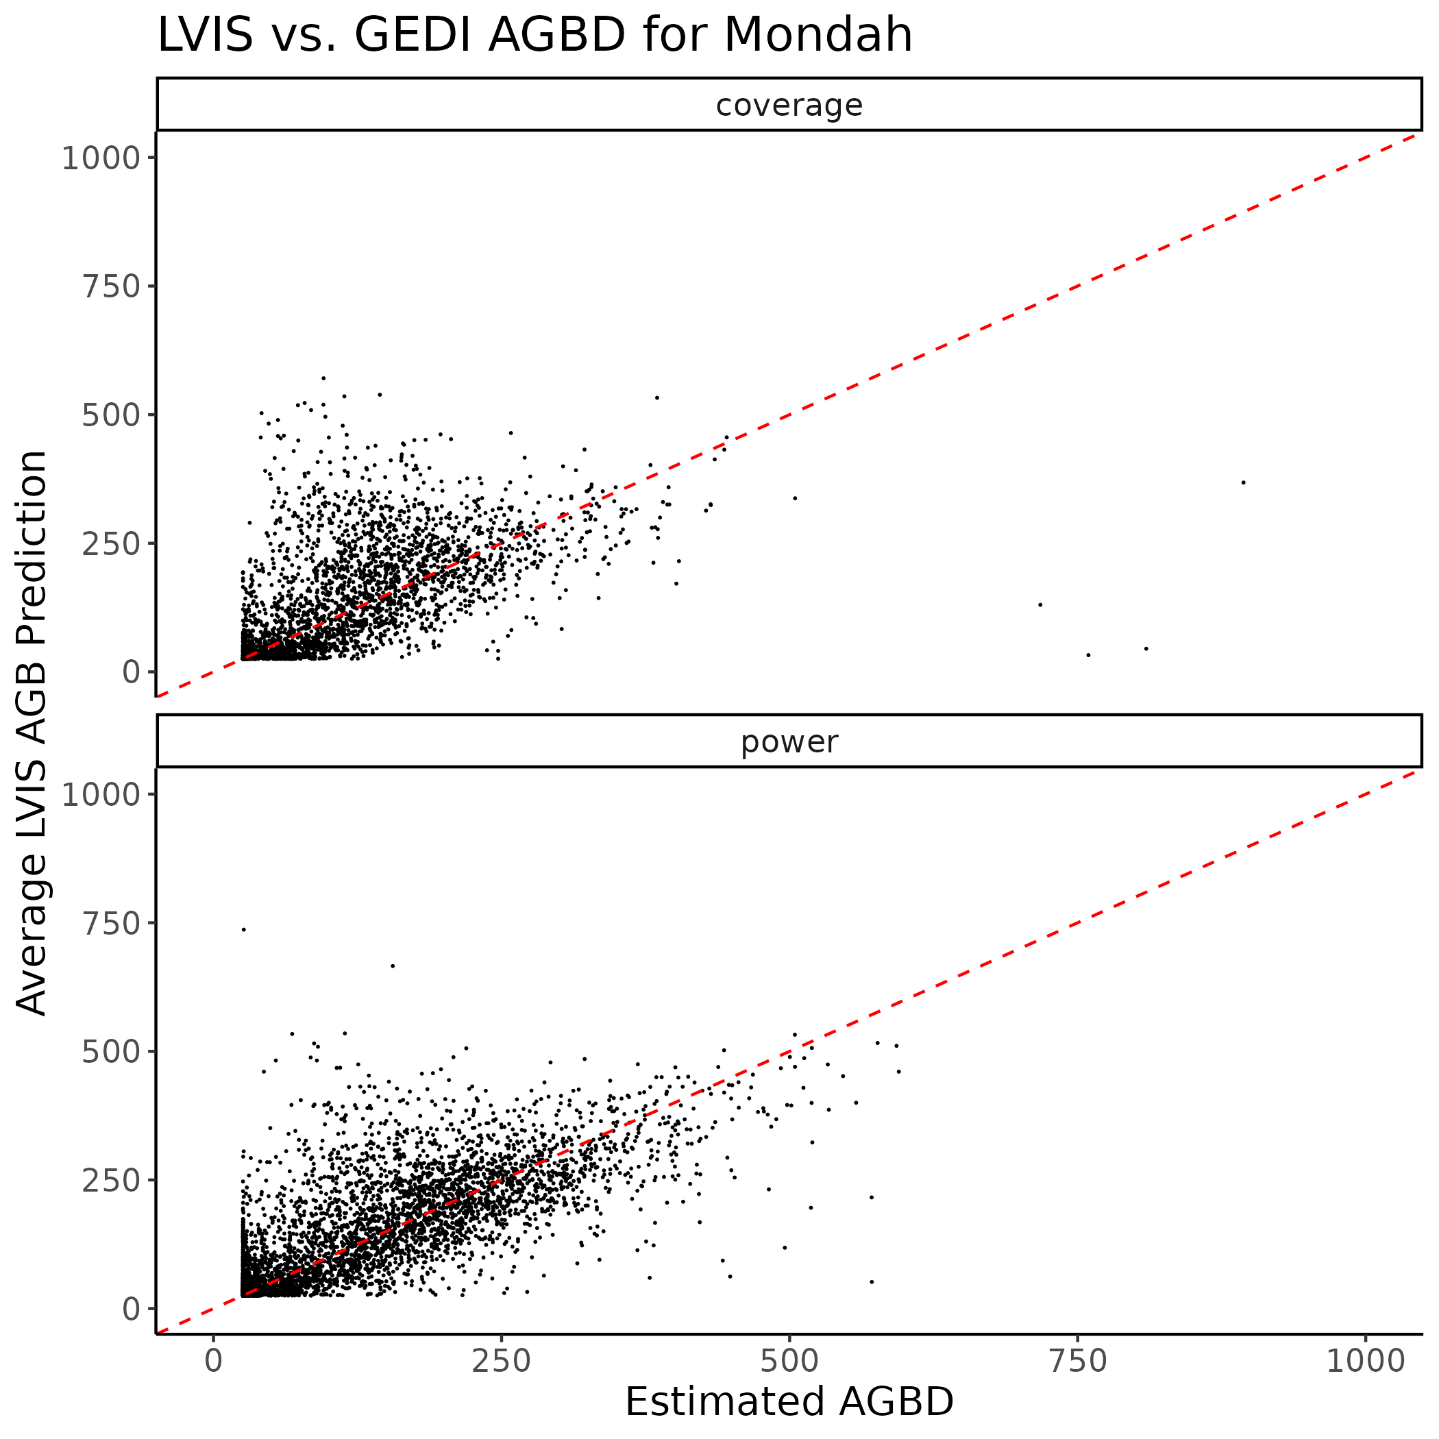

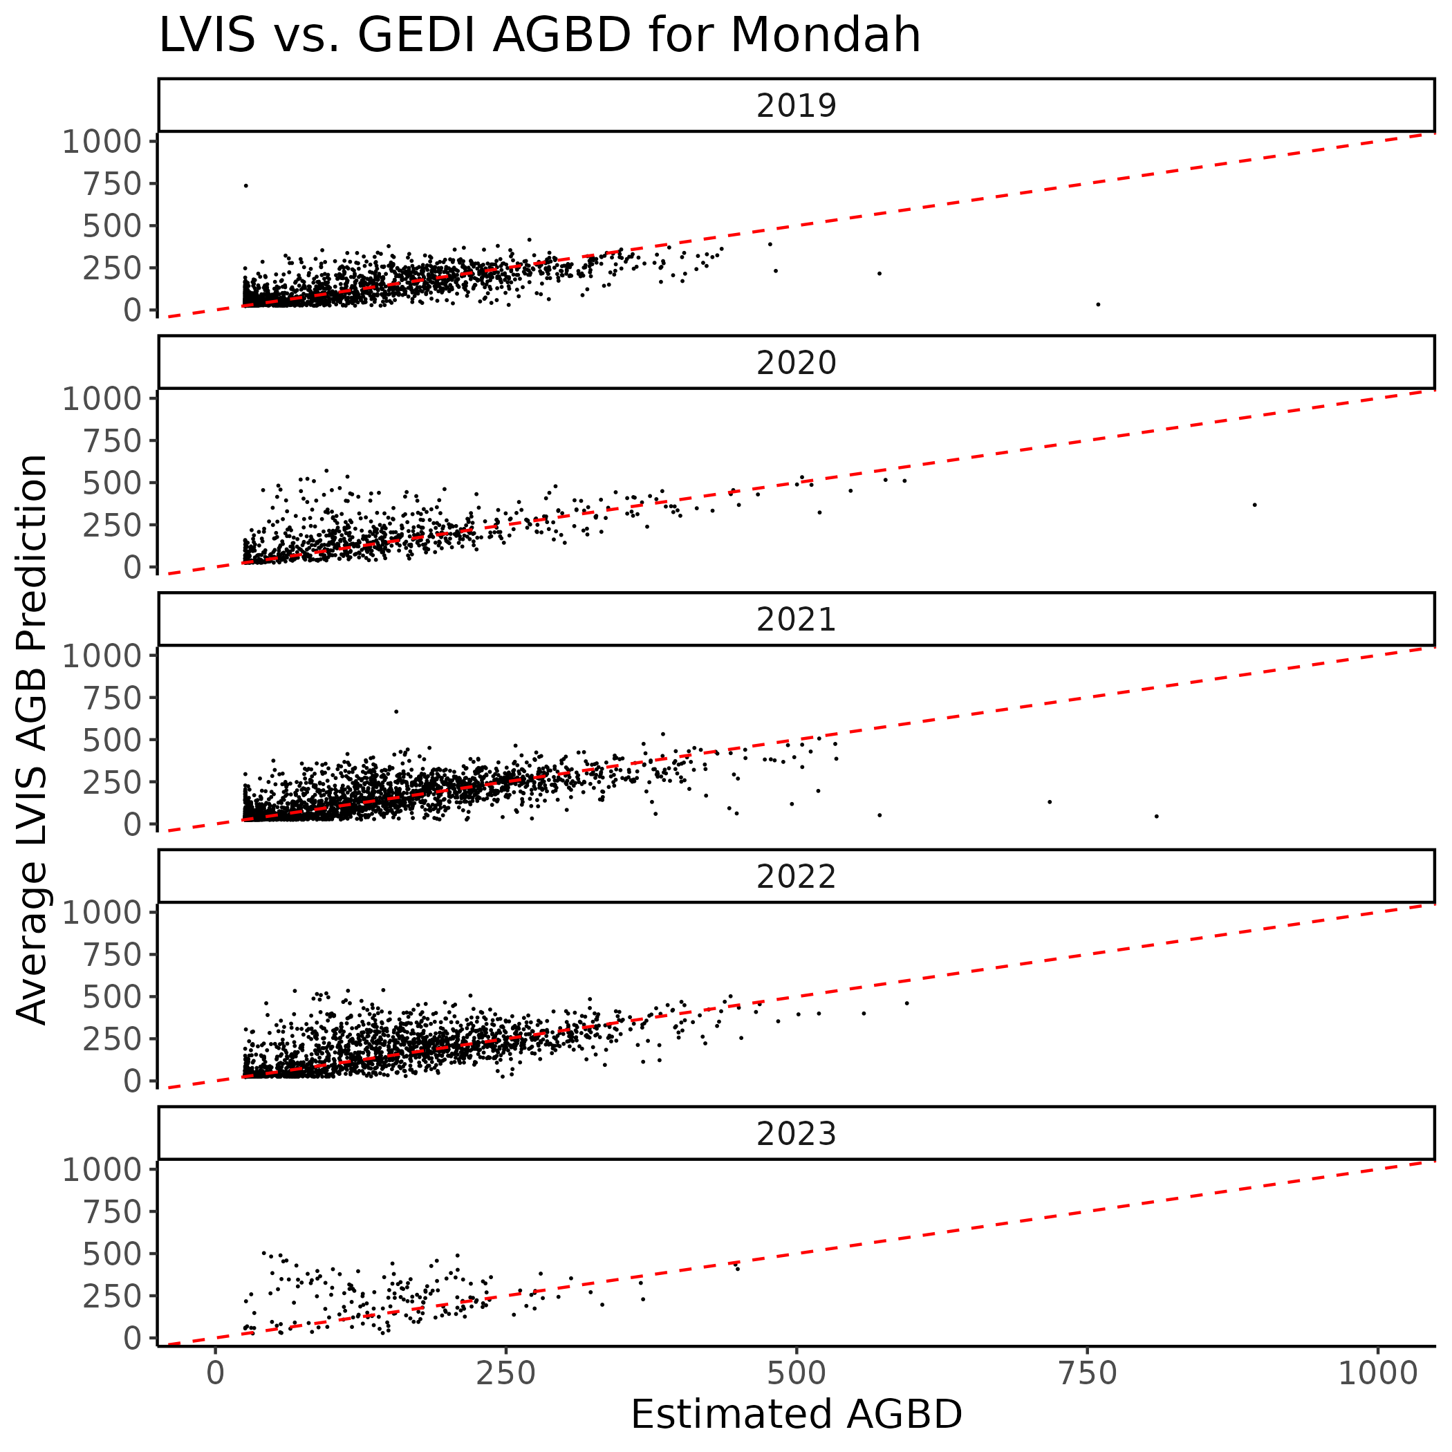

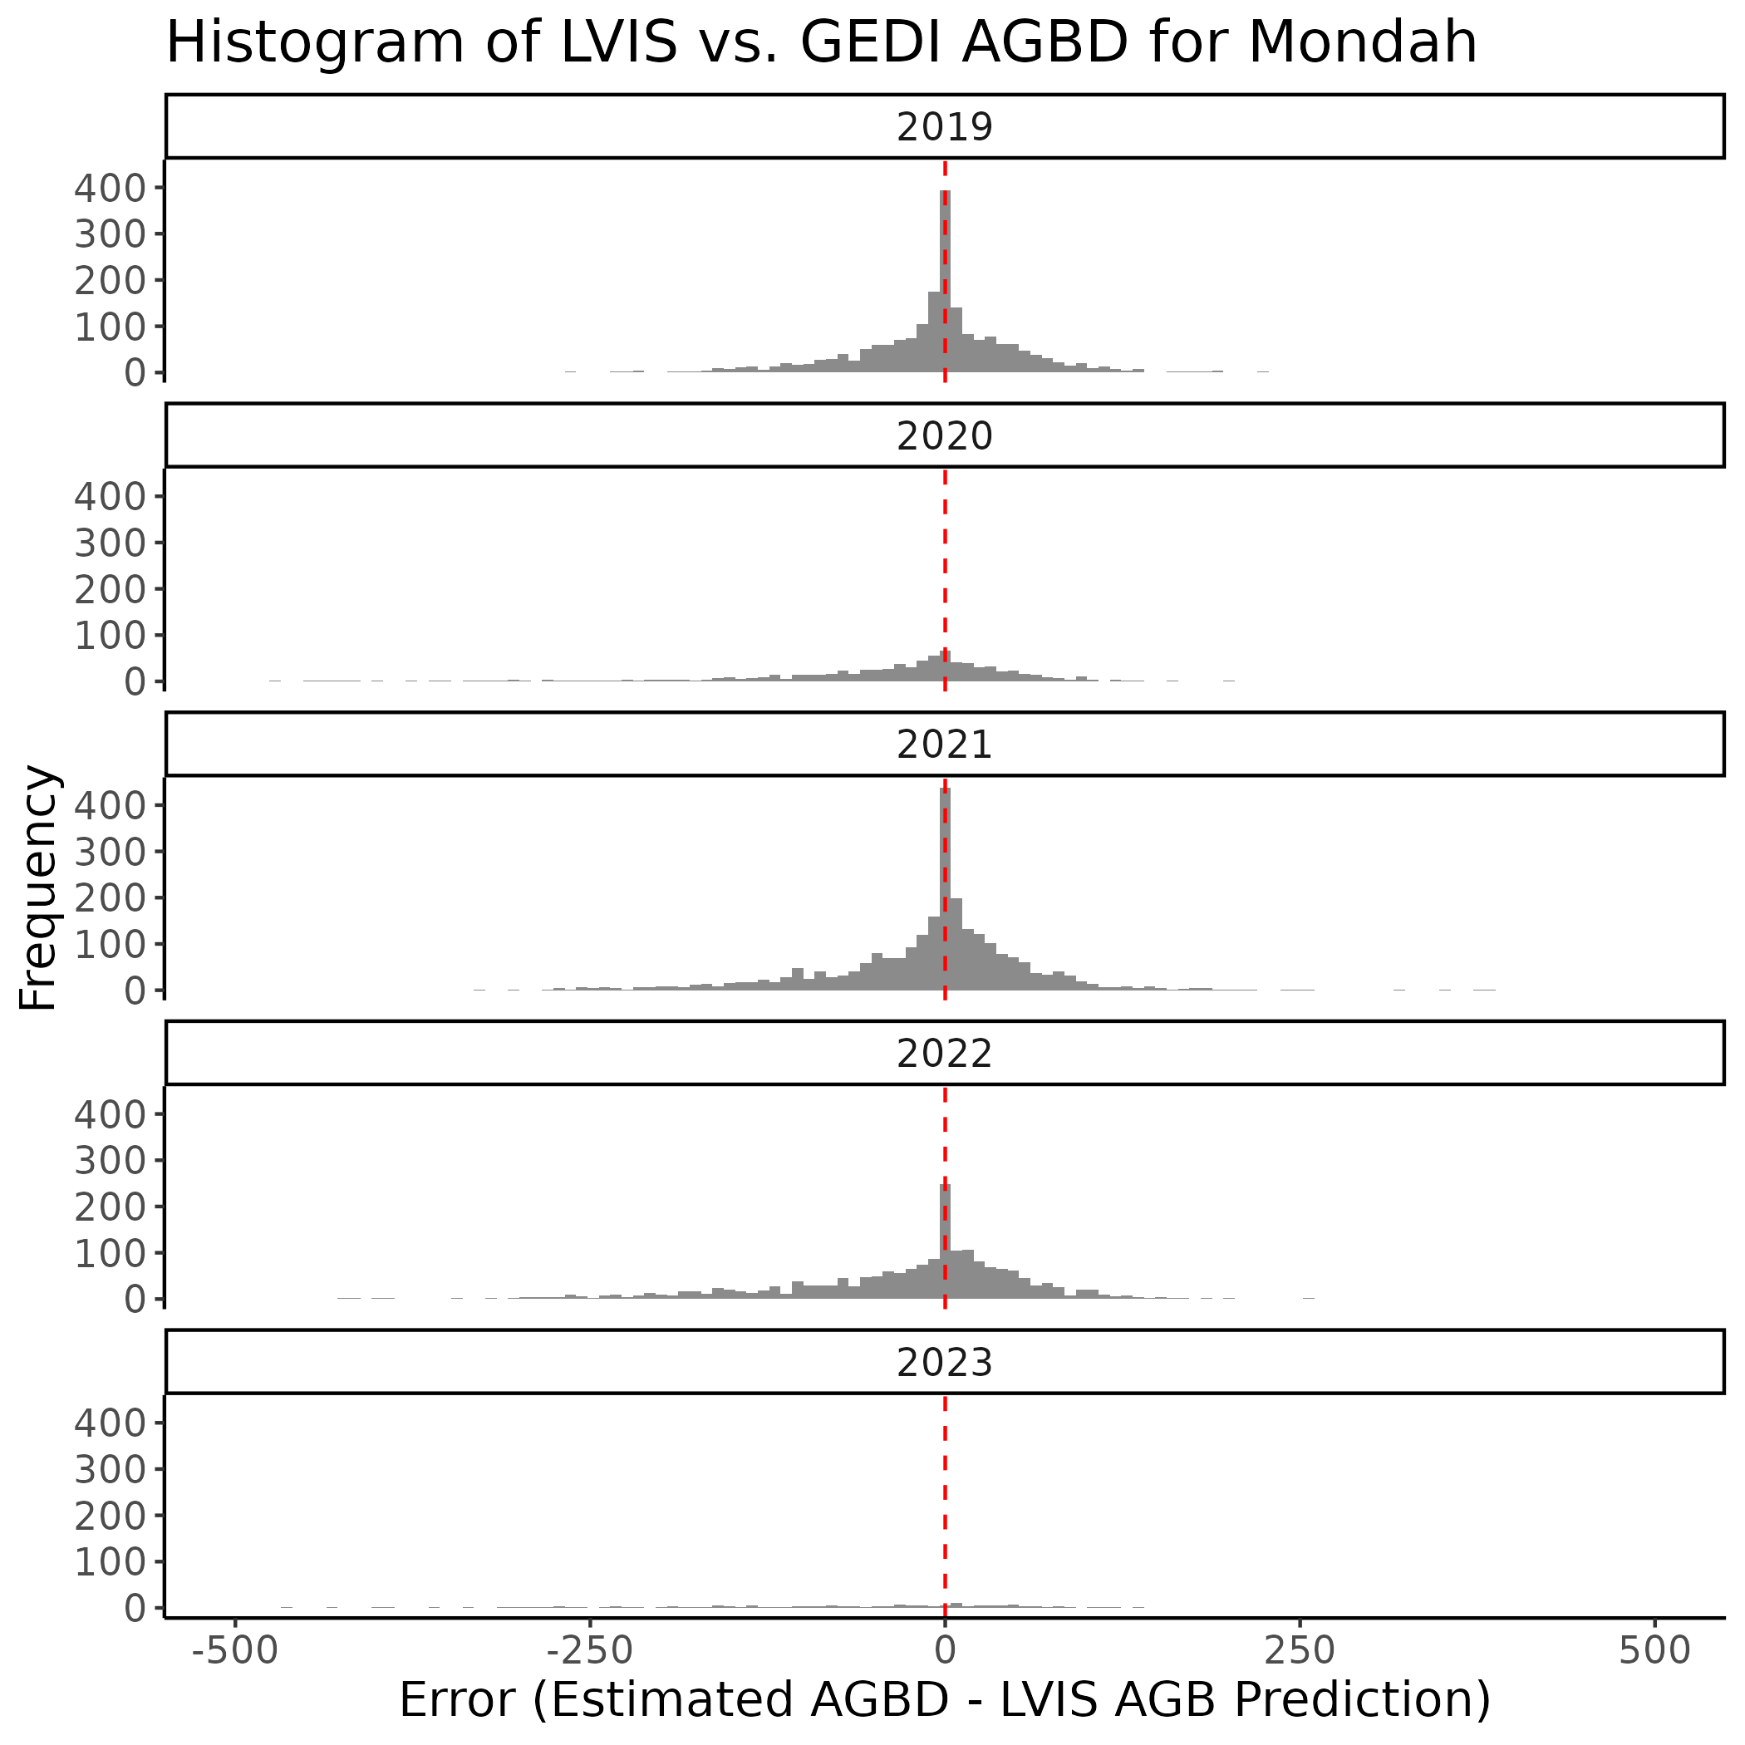

**4. Rabi**



